**Lab Test 1**

**Total: 50 marks**

**Name: Tan Ying Yao Programme: Software Engineering**

**NOTE and Instructions:**

1. This lab test requires two virtual machines: Ubuntu server and Ubuntu Desktop.
2. It is recommended to take a snapshot of virtual machine before you start the test or make changes.

**For each task, insert screenshot(s) to show the commands executed / content of a file which has been modified.**

**Make sure YOUR NAME is visible in the screenshot.**

**Complete all the following tasks:**

1. Create a new user in both Ubuntu server and Ubuntu Desktop with the following information.

* Username : **your_full_name**
* Default password : guess
* Home directory : /home/your_full_name

Command: (2 marks)

adduser tanyingyao

Screenshot (Server):

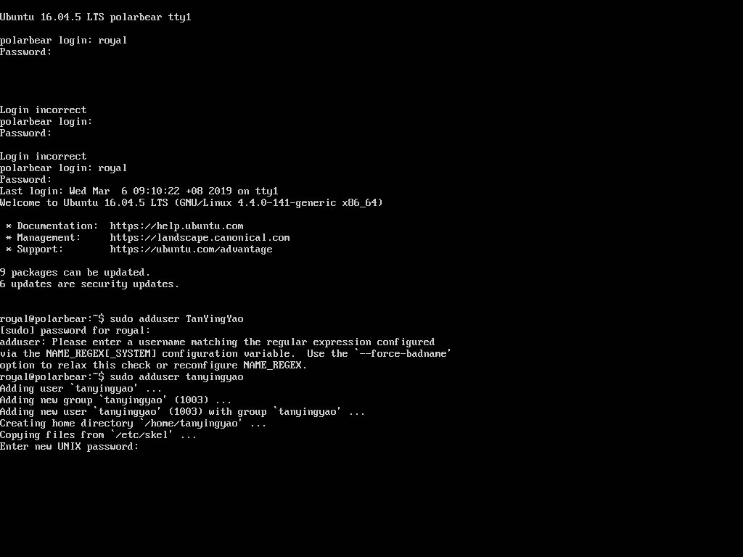 (1 mark)

Screenshot (Desktop): (1 mark)

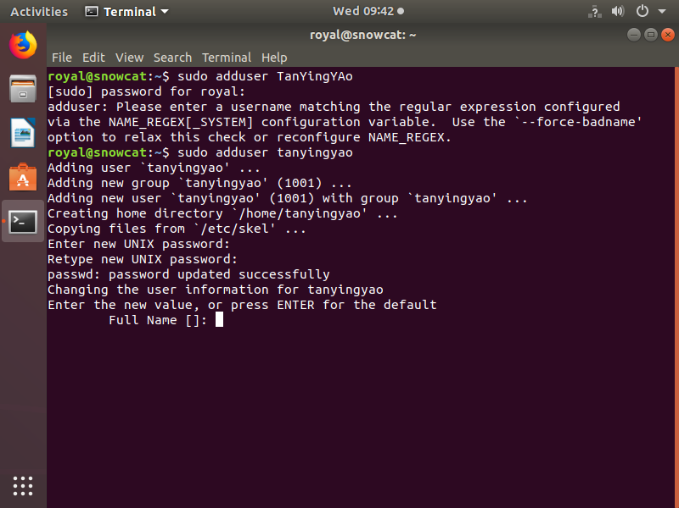

1. Allow the newly created user to perform **sudo**.

Command: **usermod -aG sudo tanyingyao** (2 marks)

Screenshot: (1 mark)

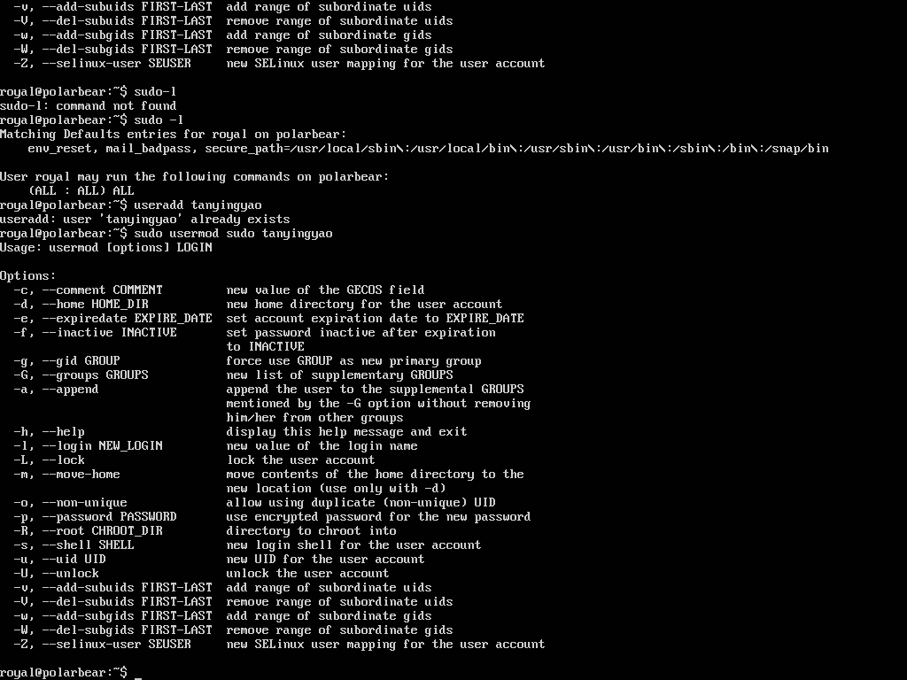

1. Check if the new user has been assigned with **sudo** privilege.

Command: sudo -l (1 mark)

Screenshot:

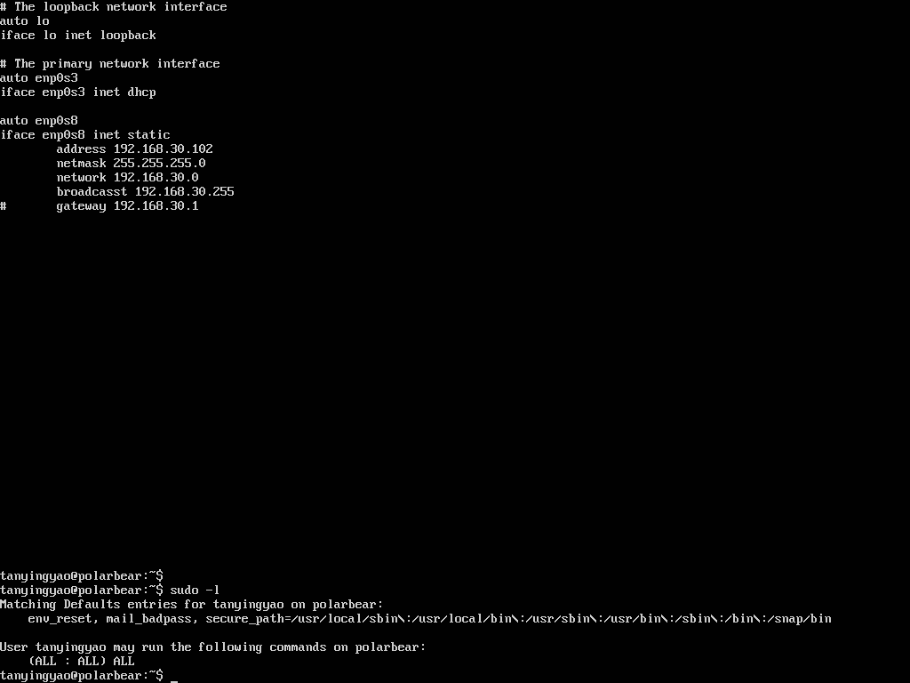 (1 mark)

# You may want to take a snapshot of Ubuntu Server before proceed.

# Log out and login again with **your_full_name**, before you proceed to the following tasks.

# Your name should appear in the prompt. Do this to both Ubuntu Server and Ubuntu Desktop.

1. Enable the **user** **quota** on root file system.

Command: sudo nano /etc/fstab (1 mark)

Screenshot of file content after changes:

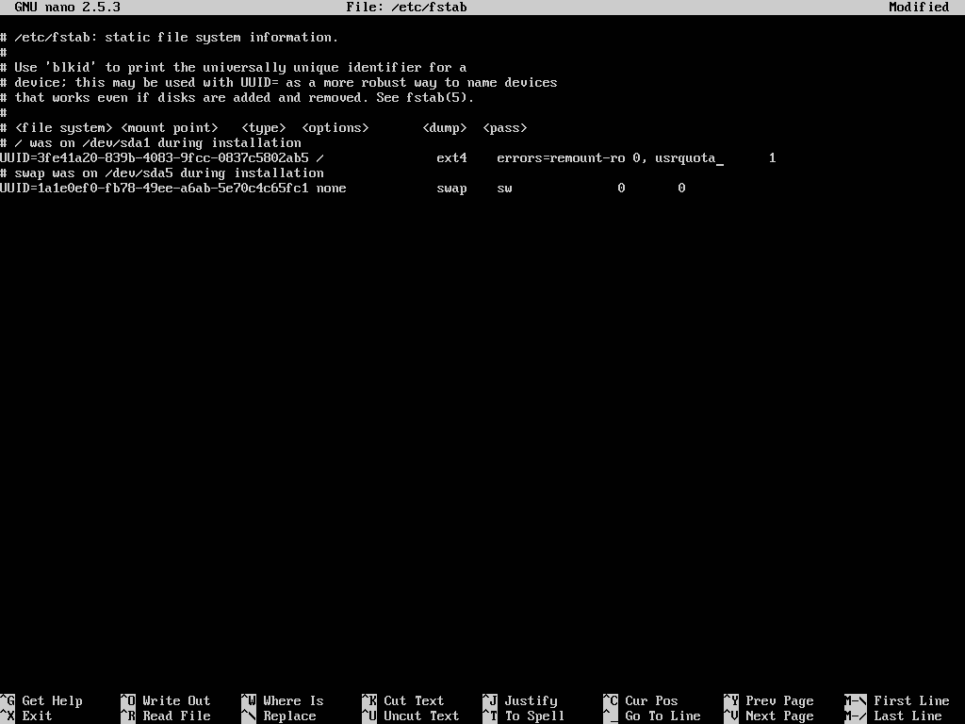 (1 mark)

1. Remount the root file system.

Command: sudo mount –o remount / (1 mark)

Screenshot: (1 mark)

1. Enable the quota support.

Command: quotacheck -avgum (2 marks)

Screenshot:

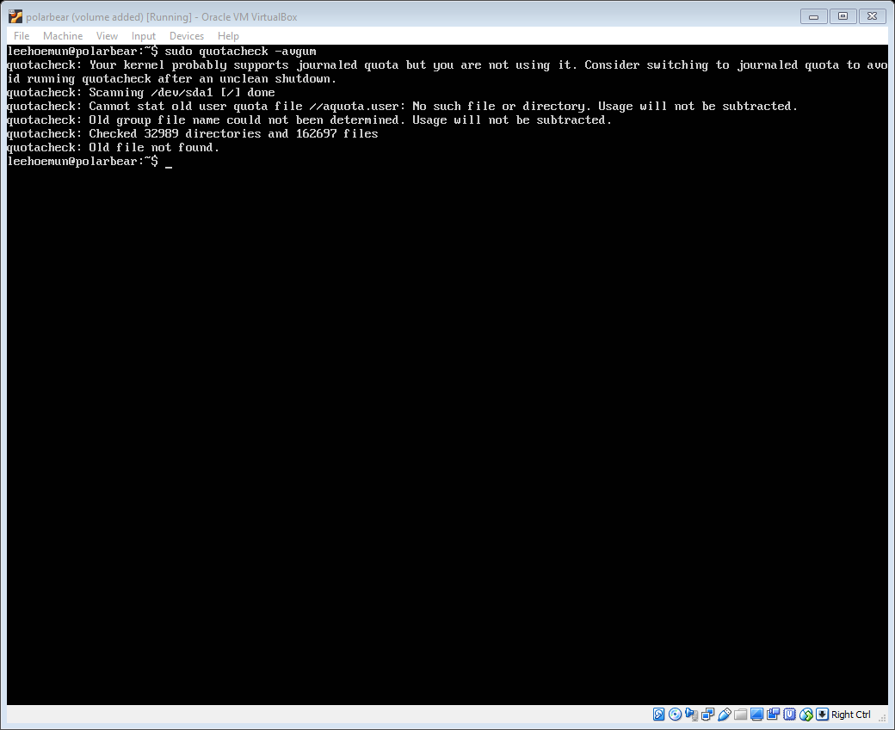

(1 mark)

1. Configure quota for yourself as follow: **soft limit 500MB**, **hard limit 550MB**

Command:edquota tanyingyao (1 mark)

Screenshot:

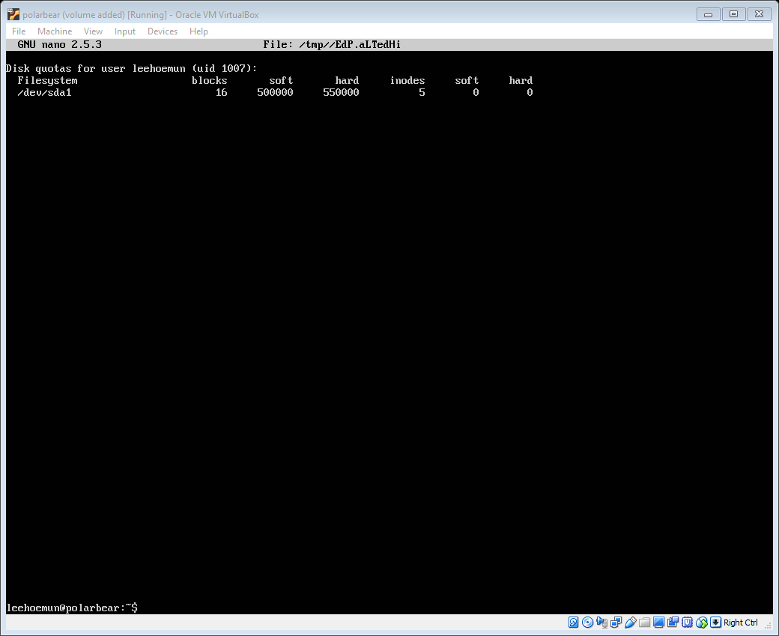

(1 mark)

1. Configure the network interface in **Ubuntu Server** and **Ubuntu Desktop** to use static IP as follow.

Ubuntu Server: 192.168.60.111

Ubuntu Desktop: 192.168.60.112

1. Command: **nano /etc/network/interfaces** (1 mark)

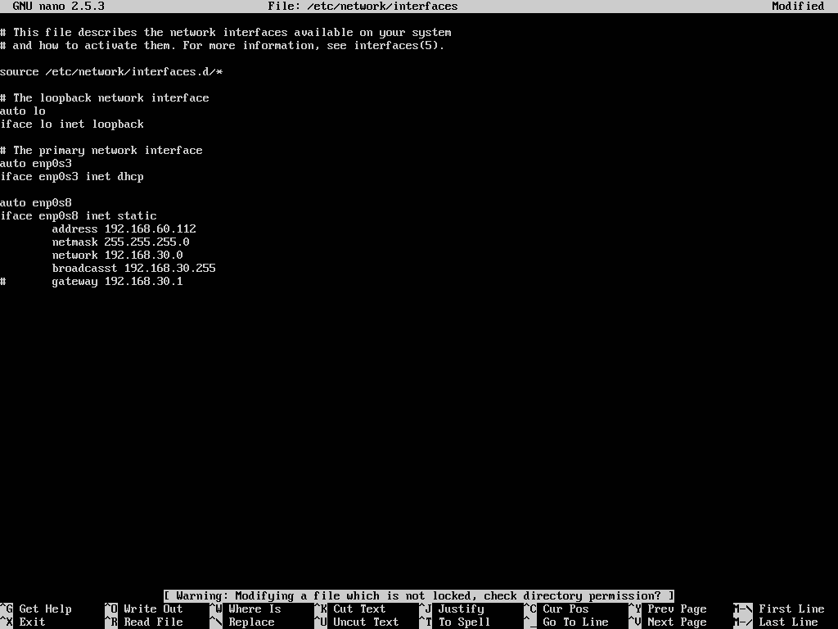

1. Command to check / show the network interface available: **ip a** (1 mark)

Screenshot: (1 mark)

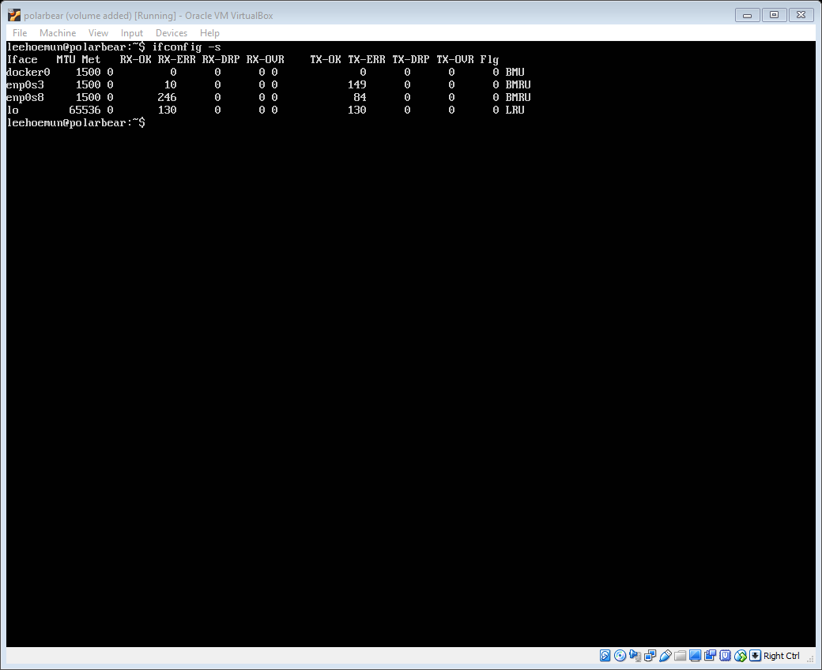

1. Modify the configuration file to apply the static IP and insert the screenshot of the **file content with the static IP configuration**.

Screenshot (Server): (2 marks)

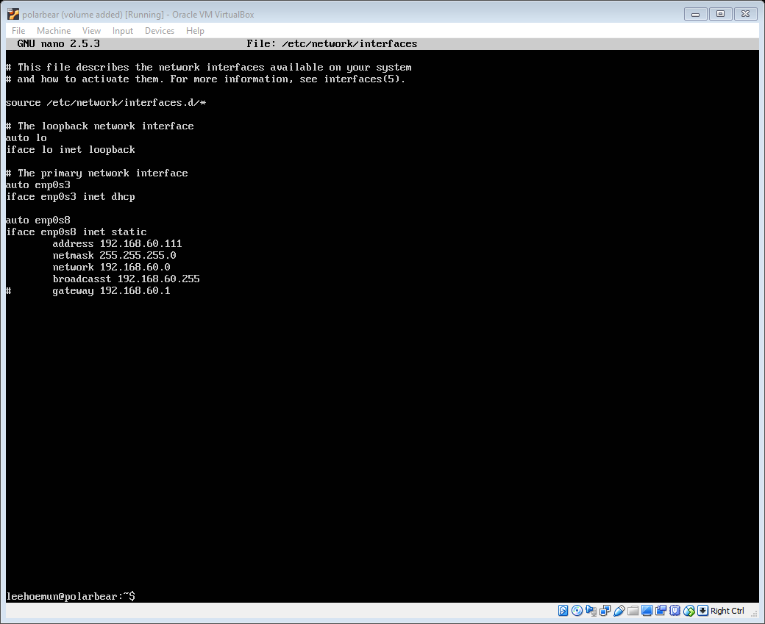

Screenshot (Desktop): (2 marks)

Edit using the GUI

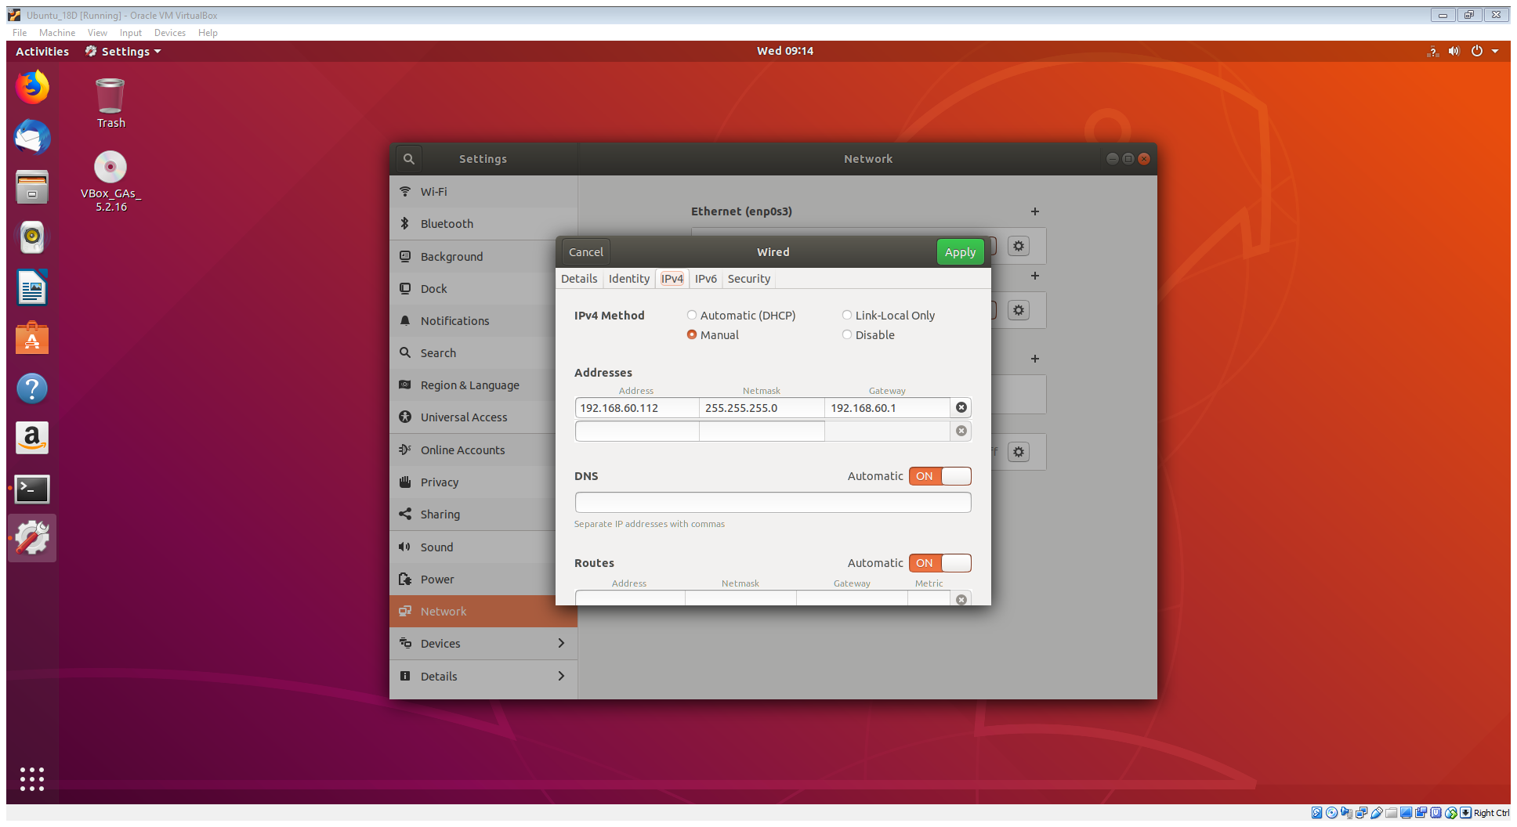

1. Make the new configuration of network interface takes effect.

Command: **systemctl restart networking.service** (2 marks)

Screenshot (Server):

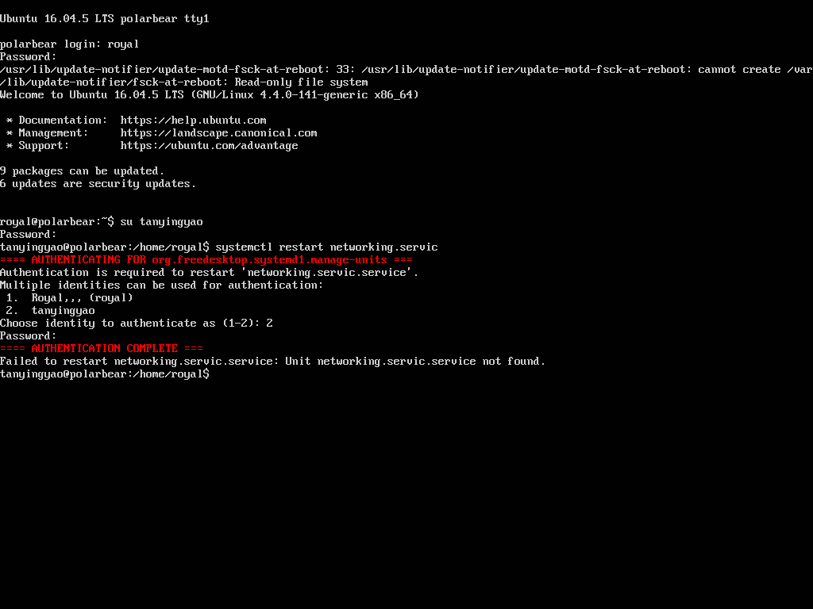 (1 mark)

Screenshot (Desktop):

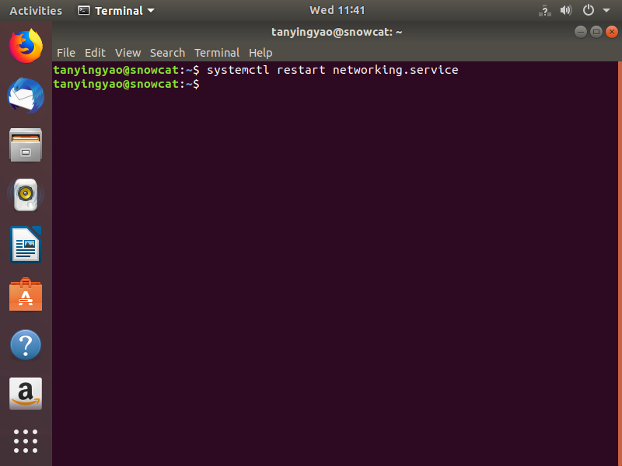 (1 mark)

1. Check if the static IP has been applied.

Command: **ifconfig** (1 mark)

Screenshot (Server):

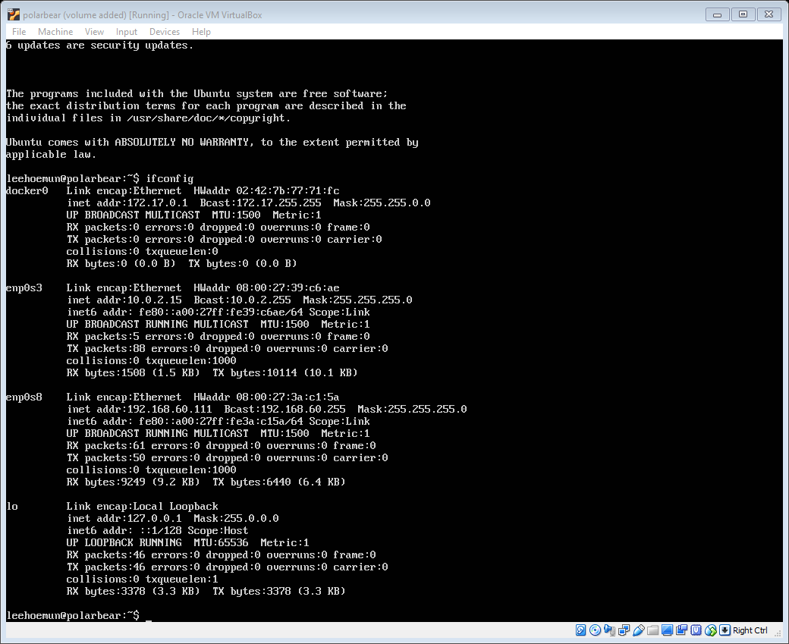 (1 mark)

Screenshot (Desktop): (1 mark)

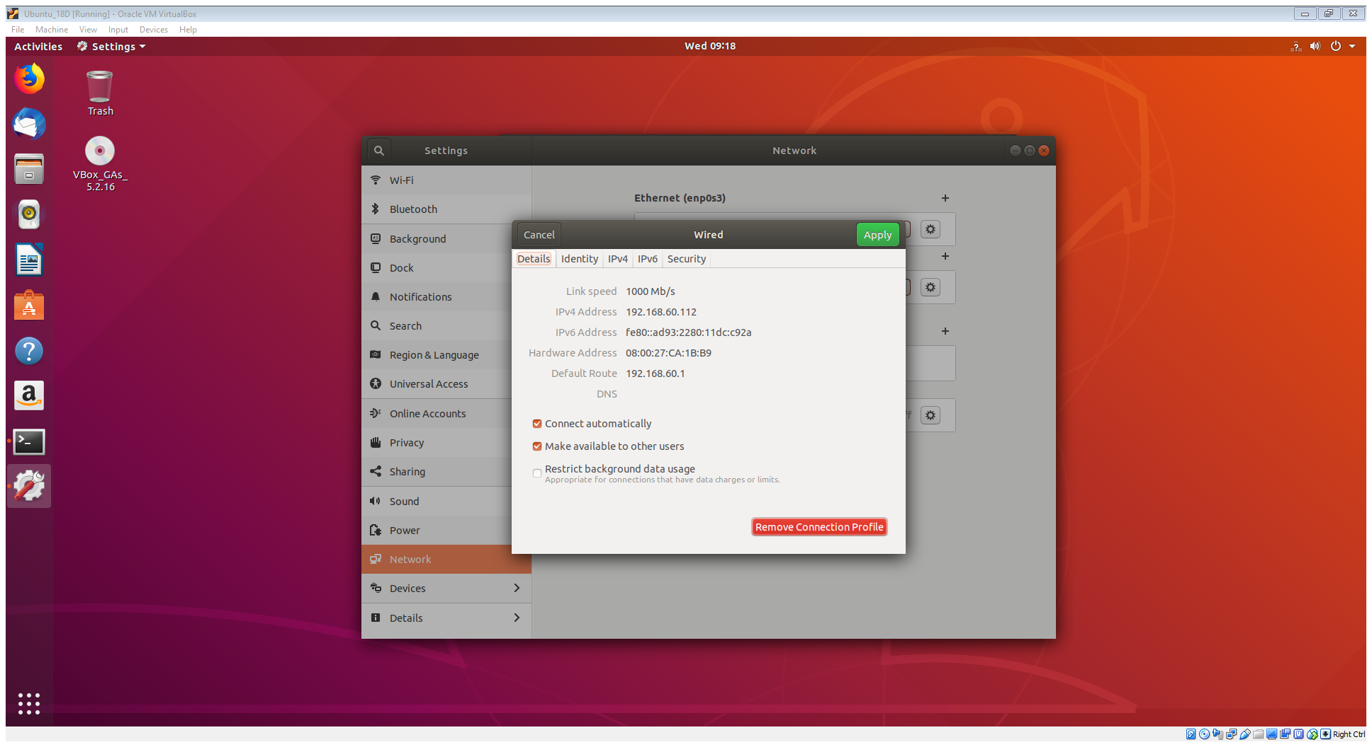

1. Check if Ubuntu Desktop can reach Ubuntu Server.

Command: **ping** 192.168.60.111

(1 mark)

Screenshot:

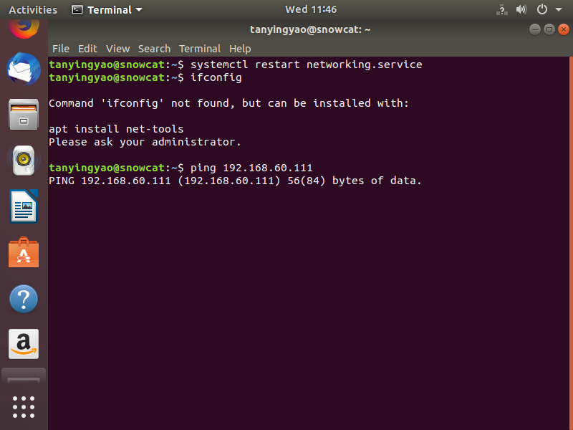

(1 mark)

1. Check if the **ssh** service is running in the server.

Command: **service ssh status** (1 mark)

Screenshot:

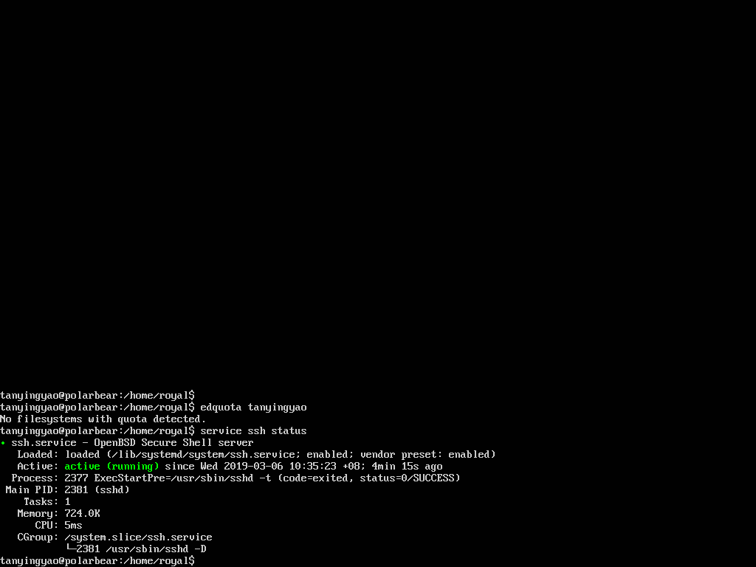 (1 mark)

1. Connect to server from Ubuntu Desktop using ssh.

Command: **ssh** 192.168.60.111

(1 mark)

Screenshot:

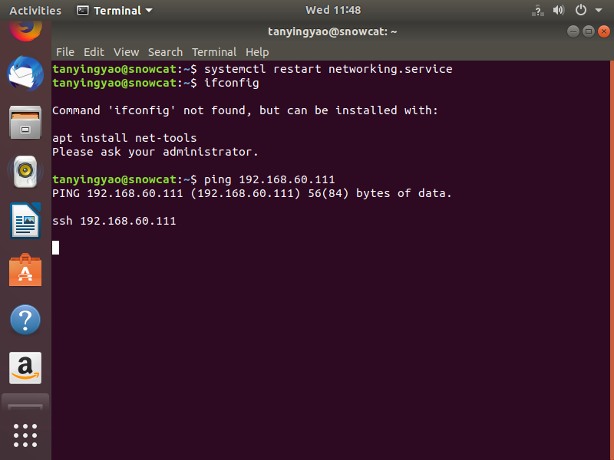

(1 mark)

1. Generate a pair of public / private keys in Ubuntu Desktop.

Command:

ssh-keygen

Screenshot:

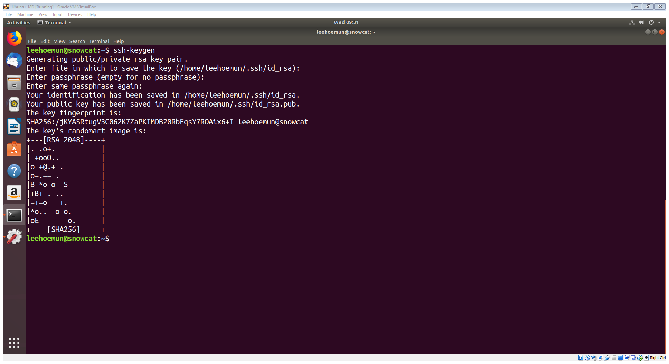 (1 mark)

1. Copy the public key to Ubuntu Server.

Command: ssh-copy-id –I ~/.ssh/id_rsa.pub 12821 192.168.60.111 (2 marks)

Screenshot: (1 mark)

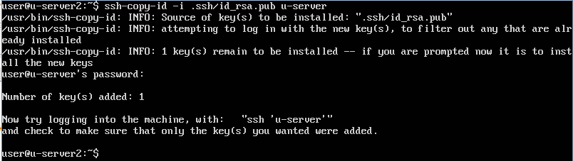

1. Change the port number for **ssh** service to 12821.

Command:nano /etc/ssh/sshd_config

Screenshot of file content after changes: (1 mark)

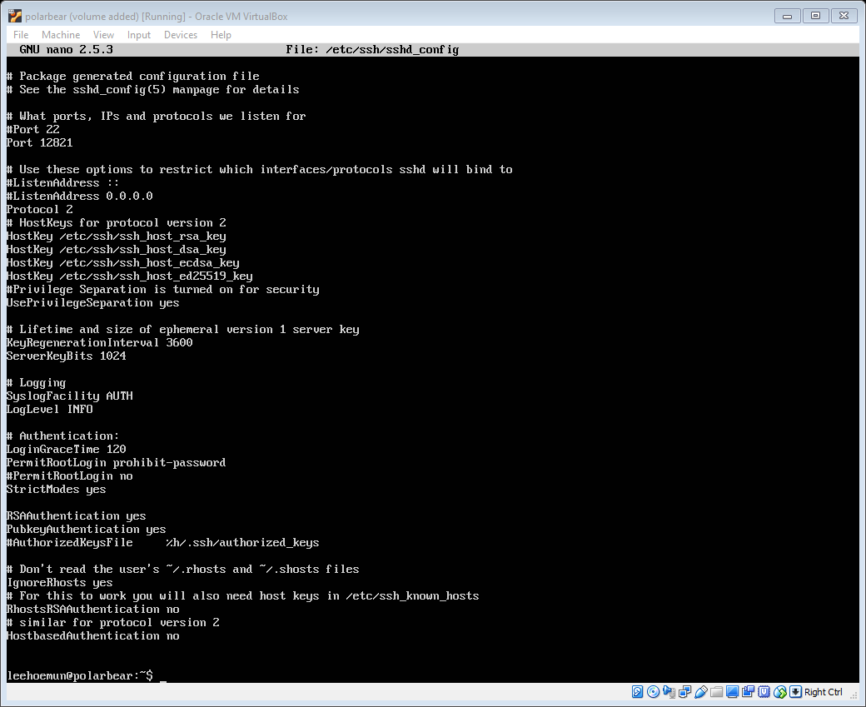

1. Restart **ssh** service.

Command: **systemctl restart ssh** (1 mark)

Screenshot: (1 mark)

s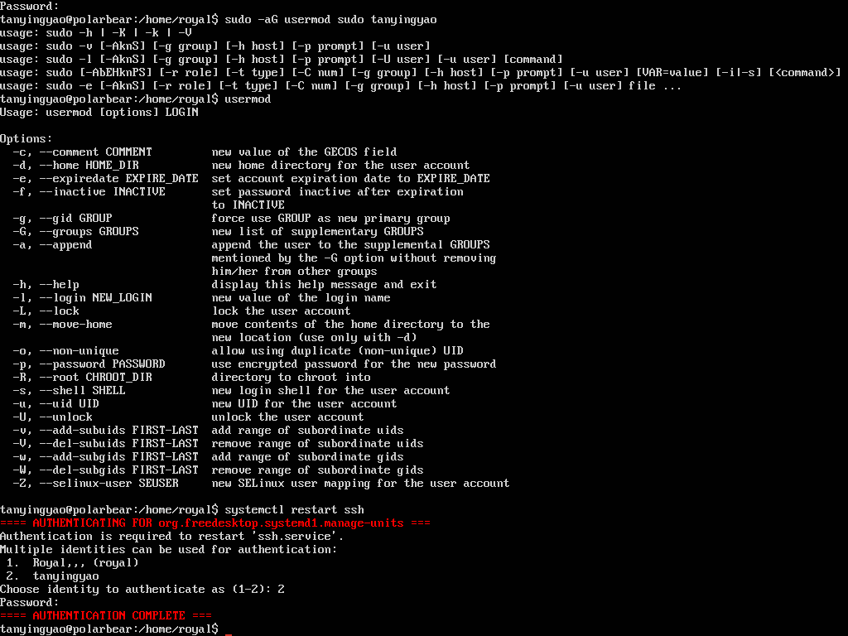

1. Check if **ssh** is listening to the new port number.

Command: netstat –tulpn | grep ssh (2 marks)

Screenshot:

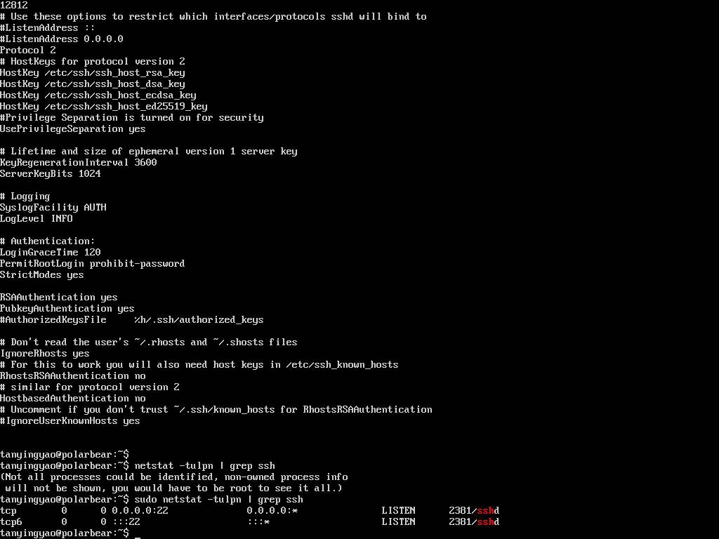 (1 mark)